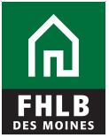

2023 Affordable Housing Program
Communication Toolkit

Toolkit Purpose

On behalf of the Federal Home Loan Bank of Des Moines (FHLB Des Moines), we would like to thank you for your support of the Affordable Housing Program (AHP). Together, we are making a profound impact on affordable housing accessibility.

This communication toolkit has been developed to assist your organization in getting the word out about your project and the AHP grant from FHLB Des Moines, building awareness of the good work you are doing in your community and increase understanding around the need for affordable housing more broadly.

For your convenience, we have this tool kit available on our public website. You can find our logo and other design elements there as well. If you need assistance with the graphics or the publicity around your AHP grant, please reach out to Julie DeVader, PR Manager, at jdevader@fhlbdm.com or 515.412.2172.

Key Message Themes

General information about FHLB Des Moines and the AHP award

Since the inception of the AHP in 1990, FHLB Des Moines has awarded approximately $735 million to provide affordable housing opportunities to more than 92,000 families and individuals. This competitive program encourages partnerships between member financial institutions and housing organizations that help provide opportunities for the purchase, construction and/or rehabilitation of affordable homeownership and rental housing units in local communities.

FHLB Des Moines returns 10 percent of its net income annually to assist with housing needs throughout its district, consisting of 13 states and three U.S. Pacific territories. This year, 60 projects totaling more than $46 million were awarded through the AHP. Five million dollars of the $46 million were voluntarily contributed. Additionally, FHLB Des Moines voluntarily contributed another $20 million in 2023 to community development in targeted areas of our district. In total, FHLB Des Moines gave 10 percent of its income and an additional $25 million back to its members to use for affordable housing and economic development purposes.

As you talk about the FHLB Des Moines Affordable Housing Program, you can use these themes to guide the discussion.

As a participant of FHLB Des Moines’ AHP, we are proud to be part of the solution to help meet the housing needs of low- to moderated-income individuals and families.

- FHLB Des Moines offers a variety of products to support the purchase, construction or rehabilitation of affordable housing through the Affordable Housing Program.
- AHP is a competitive program that encourages partnerships with housing sponsors and member institutions like ours to provide affordable housing to vulnerable populations in our communities.
- This program is one of the nation’s largest sources of grants for affordable housing projects.
[Project name and organization] has been chosen as a recipient of a 2023 Federal Home Loan Bank of Des Moines Competitive Affordable Housing Program grant.

- Grants are available to sponsors, which include nonprofits, governments, housing authorities and other qualifying organizations.
- Sponsors require the support of an FHLB Des Moines member financial institution to apply.
- Help get the word out about your organization and/or project by sharing social media posts and following FHLB Des Moines on Facebook (@Federal Home Loan Bank of Des Moines), Twitter (@FHLBDM), and LinkedIn (@Federal Home Loan Bank of Des Moines).

The unique structure of the AHP allows its members to reinvest in their own communities.

- FHLB Des Moines and its members support communities through mortgage lending, economic development and affordable housing.
- These initiatives create significant opportunities to support affordable housing efforts and provide access to safe housing for families in need.
- Access to affordable housing is a significant issue across the country. FHLB Des Moines is a champion of advancing the cause and providing resources to address this challenge.
Since its inception in 1990, the FHLB Des Moines Affordable Housing Program has contributed approximately $735 million in funding, impacting more than 92,000 families.
Sample News Release – Member Institution
Use this release with media outlets upon the announcement of the AHP grant disbursements.

NEWS RELEASE
For Immediate Release

[NAME OF FHLB DES MOINES MEMBER INSTITUTION] IN PARTNERSHIP WITH FHLB DES MOINES AWARDS AFFORDABLE HOUSING PROGRAM GRANT TO [HOUSING SPONSOR ORGANIZATION]

(DATE, CITY, STATE) – [FHLB DES MOINES MEMBER INSTITUTION], a member of the Federal Home Loan Bank of Des Moines (FHLB Des Moines), along with [HOUSING SPONSOR ORGANIZATION] were chosen to receive a Competitive Affordable Housing Program (AHP) grant for $XXX,XXX to help XX families find a safe and affordable place to call home.

POSSIBLE QUOTE FROM FHLB DES MOINES MEMBER INSTITUTION regarding this specific project/organization and mention commitment to community and other community outreach efforts.

INSERT HOUSING SPONSOR ORGANIZATION DESCRIPTION/PROJECT HIGHLIGHTS

POSSIBLE QUOTE FROM HOUSING SPONSOR ORGANIZATION

FHLB Des Moines’ competitive AHP encourages collaboration between member financial institutions and housing organizations to create affordable housing solutions for families in need. Since its inception in 1990, FHLB Des Moines and its members have helped facilitate approximately $735 million in funding to benefit more than 92,000 families through new construction and rehabilitation of owner-occupied or rental housing.

FHLB Des Moines returns 10 percent of its net income annually to assist with housing needs throughout its district, consisting of 13 states and three U.S. Pacific territories. This year, 60 projects totaling more than $46 million were awarded through the AHP. Five million dollars of the $46 million were voluntarily contributed. Additionally, FHLB Des Moines voluntarily donated another $20 million in 2023 to community development in targeted areas of its district.

“For more than 90 years, FHLB Des Moines has invested in helping communities grow and prosper. We are proud to partner with our member financial institutions to fulfill that commitment,” said Kris Williams, President and CEO, FHLB Des Moines. “We are also happy to say that in 2023, we gave $25 million in an addition to 10 percent of our earnings back to our members to invest in their communities and the people they serve. Thanks to the vision and dedication of our members and local housing sponsors, we are able to have a direct and positive impact.”
###

Sample News Release – Housing Sponsor Recipient
Use this release with media outlets upon being named a recipient of an AHP grant.

NEWS RELEASE
For Immediate Release

[NAME OF HOUSING SPONSOR/PROJECT] awarded [$XXX,XXX] through partnership with [FHLB DES MOINES MEMBER INSITUTION] and the Federal Home Loan Bank
Competitive grant program addresses need for affordable housing

(CITY, STATE) – [NAME OF HOUSING SPONSOR/PROJECT] is pleased to announce it has been selected to receive a [$XXX,XXX] grant from the Federal Home Loan Bank of Des Moines (FHLB Des Moines) through the Competitive Affordable Housing Program (AHP). The AHP provides down payment assistance, building or rehabilitation funds to organizations working to provide affordable housing options in their communities.

[NAME OF HOUSING SPONSOR/PROJECT] worked with [FHLB DES MOINES MEMBER INSITUTION] on the [PROJECT] over [X YEARS] and has been a dedicated community partner and advocate for affordable housing.

[POSSIBLE QUOTE FROM HOUSING SPONSOR/PROJECT LEADER]

[INSERT DETAILS ON PROJECT]

[POSSIBLE QUOTE FROM FHLB DES MOINES MEMBER INSTITUTION]

FHLB Des Moines’ competitive AHP encourages collaboration between member financial institutions and housing organizations to create affordable housing solutions for families in need. Since its inception in 1990, FHLB Des Moines and its members have helped facilitate approximately $735 million in funding to benefit more than 92,000 families through new construction and rehabilitation of owner-occupied or rental housing.

FHLB Des Moines returns 10 percent of its net income annually to assist with housing needs throughout its district, consisting of 13 states and three U.S. Pacific territories. This year, 60 projects totaling more than $46 million were awarded through the AHP. Five million dollars of the $46 million were voluntarily contributed. Additionally, FHLB Des Moines voluntarily donated another $20 million in 2023 to community development in targeted areas of its district.

“For more than 90 years, FHLB Des Moines has invested in helping communities grow and prosper. We are proud to partner with our member financial institutions to fulfill that commitment,” said Kris Williams, President and CEO, FHLB Des Moines. “We are also happy to say that in 2023, we gave $25 million in an addition to 10 percent of our earnings back to our members to invest in their communities and the people they serve. Thanks to the vision and dedication of our members and local housing sponsors, we are able to have a direct and positive impact.”

###

At the end of the news release, you may add the following.

About Federal Home Loan Bank of Des Moines

The Federal Home Loan Bank of Des Moines is deeply committed to strengthening communities, serving 13 states and three U.S Pacific territories as a member-owned cooperative. We work together with over 1,200 member institutions to support affordable housing, economic development and community improvement.

FHLB Des Moines is one of 11 regional Banks that make up the Federal Home Loan Bank System. Members include community and commercial banks, credit unions, insurance companies, thrifts and community development financial institutions. The Des Moines Bank is wholly owned by its members and receives no taxpayer funding. For additional information about FHLB Des Moines, please visit www.fhlbdm.com.

Social Media Templates
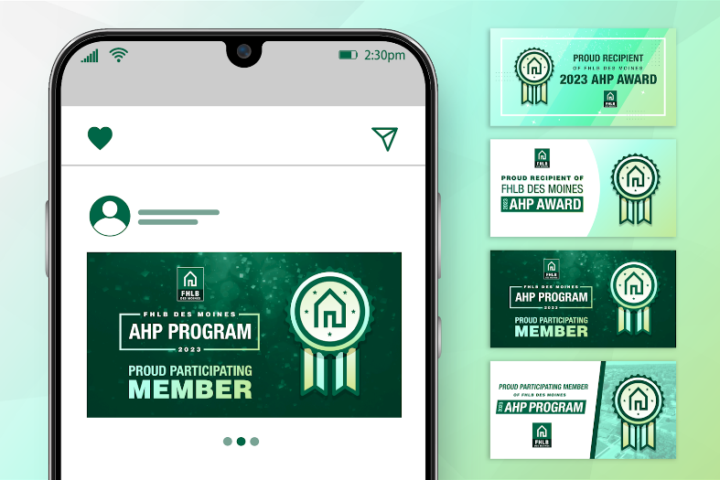
Use the following social media template messages on your own social media platforms to share the news of your award and to raise awareness for your project in the community.

Visit https://www.fhlbdm.com/products-services/affordable-housing/2023-ahp-press-kit-/ for additional social media resources and guides.

There are downloadable images available for immediate use. Increase brand awareness by adding your logo to the design files provided.

When sharing the news, be sure to tag FHLB Des Moines. Tags will help increase the reach of your post and allow FHLB Des Moines as well as other community stakeholders to like, comment and share.

Twitter: @FHLBDM
Facebook: @Federal Home Loan Bank of Des Moines
LinkedIn: @Federal Home Loan Bank of Des Moines

FHLB Member Social Option #1
Thank you to @Federal Home Loan Bank of Des Moines for partnering with us to secure [$xxx,xxxx] in grant funding to support [Housing Sponsor Organization] through the 2023 Affordable Housing Program. This project will result in the [creation or rehabilitation] of [#] units of affordable housing in [City/State].

[Sentence or two about project/impact or quote from your company]

The FHLB Des Moines Affordable Housing Program is a competitive program that encourages partnerships with housing sponsors and member institutions like ours to provide affordable housing to vulnerable populations. The program has facilitated approximately $735 million in funding since the inception of the program in 1990. Learn more: [link to press release]

#FHLBDesMoinesAHP #AffordableHousing

FHLB Member Social Option #2
As a member institution of @FHLBDM, we are proud to support affordable housing in our community through [Housing Sponsor Organization/project name]. The project was recognized by the Federal Home Loan Bank of Des Moines through the Affordable Housing Program with a [$XXX,XXX] grant! Learn more: [link to press release]

#FHLBDesMoinesAHP #AffordableHousing

Sponsor Social Option #1
[Housing Sponsor Organization] is proud to announce we have been awarded [$xxx,xxxx] in Affordable Housing Program grants from @Federal Home Loan Bank of Des Moines. This award, sponsored by [member financial institution] will support [project details] and commits to the [creation or rehabilitation] of [#] of homes in [City/State].

[sentence or two about project/impact or quote from your company]

Learn more: [link to press release]

#FHLBDesMoinesAHP #AffordableHousing

Sponsor Social Option #2
🏠 We are thrilled to announce the collaboration between [Housing Sponsor Organization] and [member financial institution] in successfully securing [$XXX,XXX] in grant funding through the Federal Home Loan Bank of Des Moines Affordable Housing Program. With this critical grant funding, [Housing Sponsor Organization] is now empowered to make a significant impact in addressing housing challenges in [state] with our latest project that commits to the [creation or rehabilitation] of [#] homes. Learn more: [link to press release]

#FHLBDesMoinesAHP #AffordableHousing

